CMPE 314

Fall 2018

Clippers and Clampers

Joshua Bastian

Hamzah Mamood

10/9/18

Riu Rjoopan

1. Purpose

The purpose of this lab is to observe constraining signal inputs otherwise known as “clipping” by a resistive voltage and the concept of “clamping” which is shifting the DC level of the steady state AC signal.

1. Equipment



* Diodes 14738
* 2 10K and 1 100k resistors
* Capacitor .22uF

1. Procedure
2. Construct the circuit in Figure 1 but without the resistor
3. Apply a sinusoidal wave with amplitude of 6V and frequency 10kHz as the input voltage V1, plot out the input and output waveforms
4. Repeat step 2 with a square wave and a saw tooth wave
5. Construct the circuit in Figure 2
6. Apply a sinusoidal wave of amplitude 4V and a frequency of 10kHz as the input voltage
7. Plot out both input and output waveforms
8. Repeat step 5 with a square wave of peak 2V and a valley of -4V
9. Repeat step 5 and 6 and change Vb to 1V
10. Graphs

Part A Clipper Circuit Sine Wave without R2 Experimental:

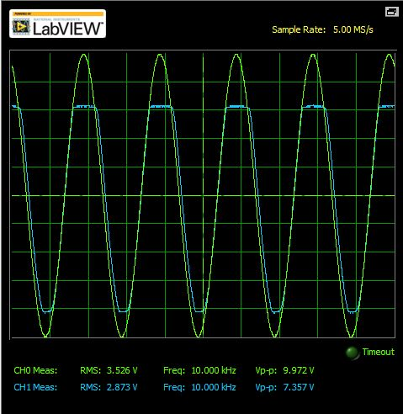

Theoretical:

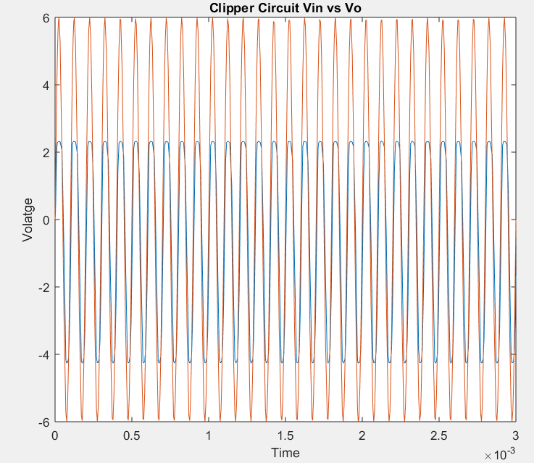

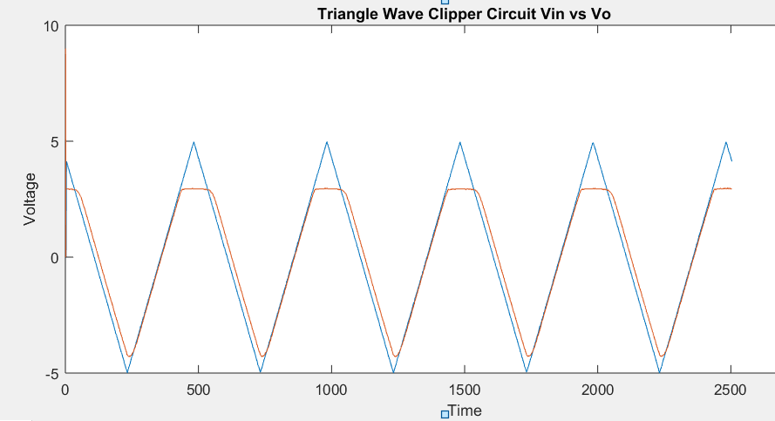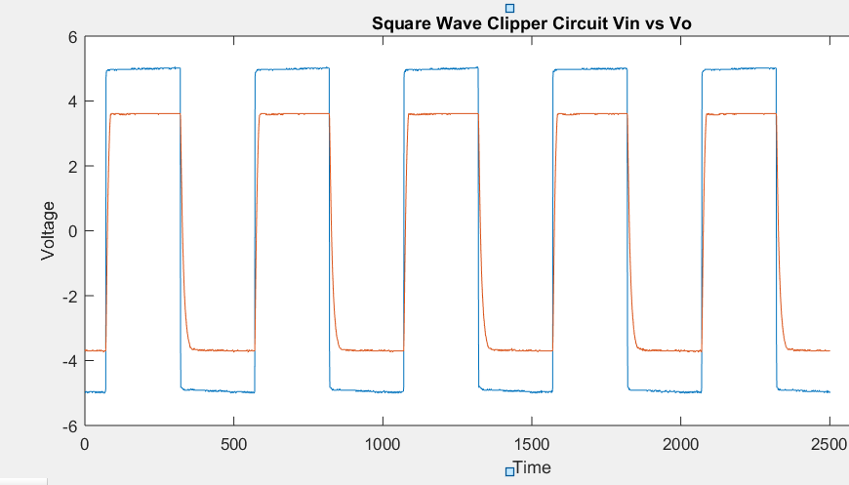Square Wave: Triangle Wave:

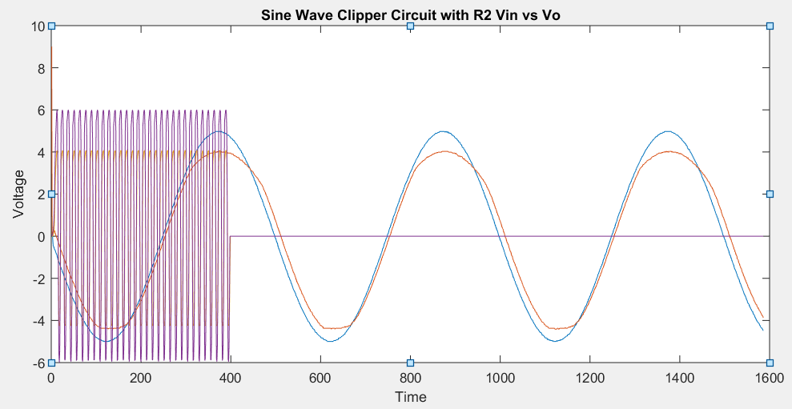Part B Clipper with R2 Theoretical vs Experimental

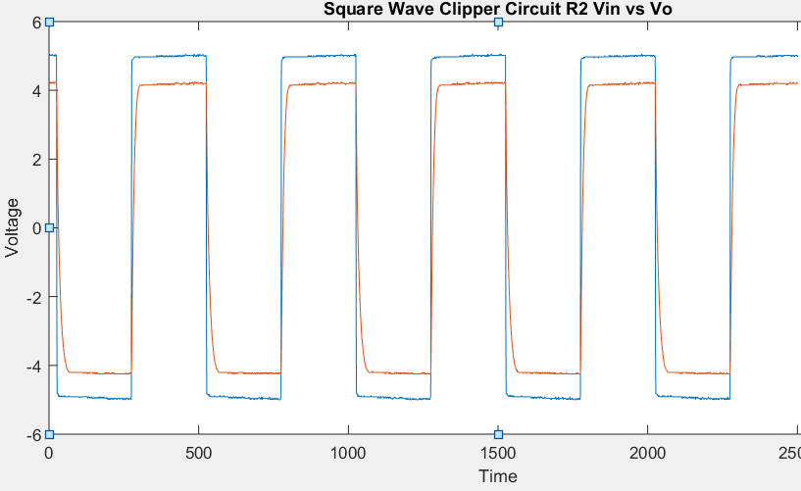Square Wave Part B

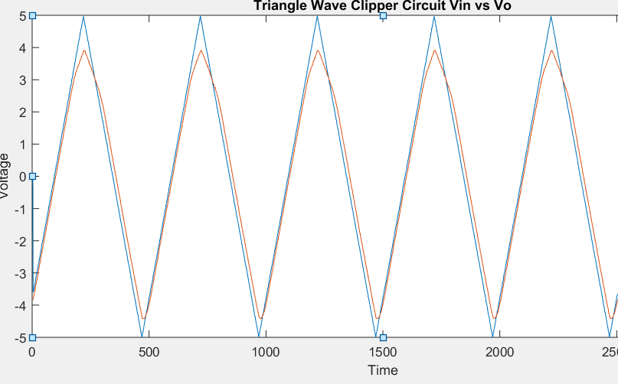Triangle Wave Part B

Clamping Circuit Sine Wave

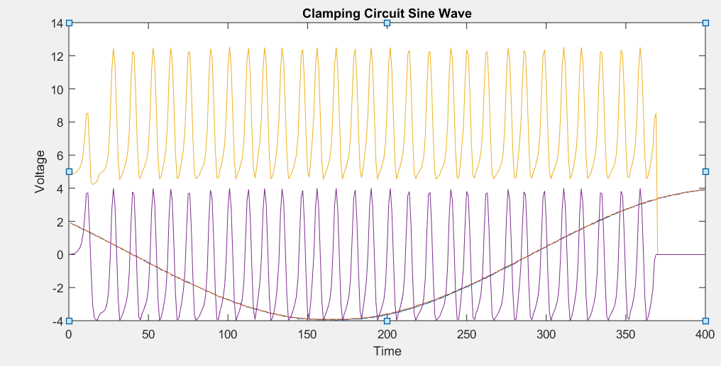

Clamping Circuit Square Wave:

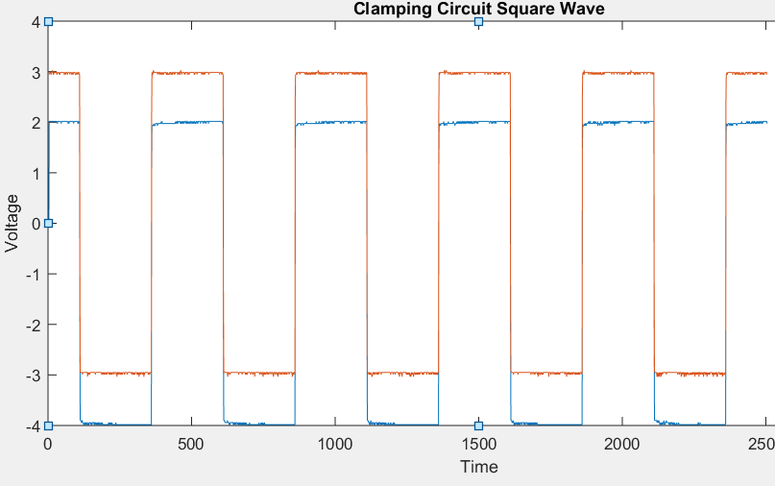

1. Calculations

A)

When $V_{I}-2> V_{γ} or V_{I}> V_{r1}+2$

$D_{1}$ = on



$D_{2}=off$ $V_{o}=V_{γ}+2$

When –( $V_{I}+4> V_{γ2} or V_{I}< -(V_{γ2}$– 4)

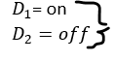 -($V_{γ2}+4)$

When -($V_{γ2}+4)<V_{I}< V_{γ1}+2$

$V_{o}=V_{I}$

1. Conclusions

This lab we observed both clipping and clamping circuits In the clipping circuits we could see how the output voltages amplitude gets clipped off. With the clamping circuit from the graphs shown we see and a shift of the output voltage down as it shifts the DC level of the steady state AC signal. Spikes in a signal when it comes to FM can be adjusted using a clipper circuit to prevent the signal prom spiking past a certain level. A real life example of a clamper is For the protection of the amplifiers from large errant signals. The data from comparing the theoretical and experimental values were hard to read because of the major difference in the time scale, if that was more controlled a better observation of theoretical and experimental data would’ve been recorded.